INVITATION

Final Conference
DETOUR – Towards Pre-Trial Detention as Ultima Ratio

Dilemmas of Pre-trial supervision

Location: Federal Ministry of Justice, Austria, Museumstraße 7, 1070 Wien, (Please bring an ID with you!)
Date and time: Thursday 9th of November 2017, 10.00 am till about 5.00 pm
Welcome reception – Meet colleagues from other countries: Wednesday 8th of November 2017, 7.30 pm, Federal Ministry of Justice, Austria

Across Europe, the pre-trial process poses dilemmas for judges, prosecutors, defense lawyers, probation services, and the police. The pre-trial process also poses fundamental dilemmas for national legal systems and the European Union as a whole.

At this conference, research carried out in seven European Union Member States (Austria, Germany, the Netherlands, Belgium, Romania, Lithuania and Ireland) will be presented - it poses fundamental, urgent, and practical questions about the use of pre-trial supervision. Practitioners from the participating countries will comment on the outcomes and all participants are invited to contribute to the discussions.

This conference is aimed at: judges, prosecutors, lawyers, probation services, academics, non-governmental organizations and policymakers.

- Please register as soon as possible: Participation in the conference is free of any fee, the number of participants is however limited! Send the filled in registration form (see below) to veronika.reidinger@irks.at, the latest by 30th of October 2017.
- For further information on the conference contact veronika.reidinger@irks.at
- Conference language is English

Program

09:30 | Arrival and registration
10.00 | Welcome | Dr. Walter Hammerschick, IRKS, Project Director  Mag. Christian Pilnacek, Director General Penal Law, Federal Ministry of Justice of the Republic of Austria
10:15 | What have we learned? Insights and recommendations from the DETOUR Project  The practice of pre-trial decision-making in the EU and its effects: latest Developments | Prof. Dr. Christine Morgenstern, University of Greifswald/Free University Berlin  Ralph Bunche, Regional Director, Fair Trails Europe
11:30 | Dilemmas and challenges in the work of defense lawyers | Dr. J.M.W. Lindeman, University of Utrecht, the Netherlands  Philip Daeninck, Bar Association, Hasselt, Belgium  Jaap Baar, Defense Lawyer, the Netherlands (to be confirmed)
12:30 | Lunch break
13:30 | Through the lens of liberty or detention: the starting point for decisions on pre-trial detention | Dr. Mary Rogan, Trinity College Dublin, the University of Dublin, Ireland  Gráinne Glynn, Head of the Appeals Section, Office of the Director of Public Prosecutions, Ireland  Mag. Friedrich Forsthuber, President of the Vienna Regional Court for Criminal Matters, Austria
14:30 | Dilemmas of alternatives to pre-trial detention | Dr. Eric Maes and Dr. Alexia Jonckheere, National Institute of Criminalistics and Criminology (NICC), Belgium  Annie Devos, Director-General of Houses of Justice, Wallonia-Brussels Federation & Expert to the Council for penological co-operation (PC-CP) Working Group , Council of Europe, Strasbourg  Dr. Iris Killinger, KSK attorneys, Hamburg, Germany
15:30 | Coffee break
15:45 | European Dimensions | Prof. Dr. Christine Morgenstern, University of Greifswald/Free University Berlin  Prof. Dr. Ioan Durnesco, Association of Schools of Social Work in Romania  NN
16:45 | Closure

Registration
for
Dilemmas of Pre-trial supervision
DETOUR – Towards Pre-Trial Detention as Ultima Ratio
Final Conference, 9th of November 2017
At the Austrian Ministry of Justice,
Museumstraße 7, 1070 Wien

Mr/Mrs
Name:
Organization:

Participates in the conference. In case of an inability to attend the organizers of the conference will be informed as soon as possible.

Signature:

Please send the signed registration via mail to veronika.reidinger@irks.at

Venue:
Federal Ministry of Justice, Austria, Museumstraße 7, 1070 Wien

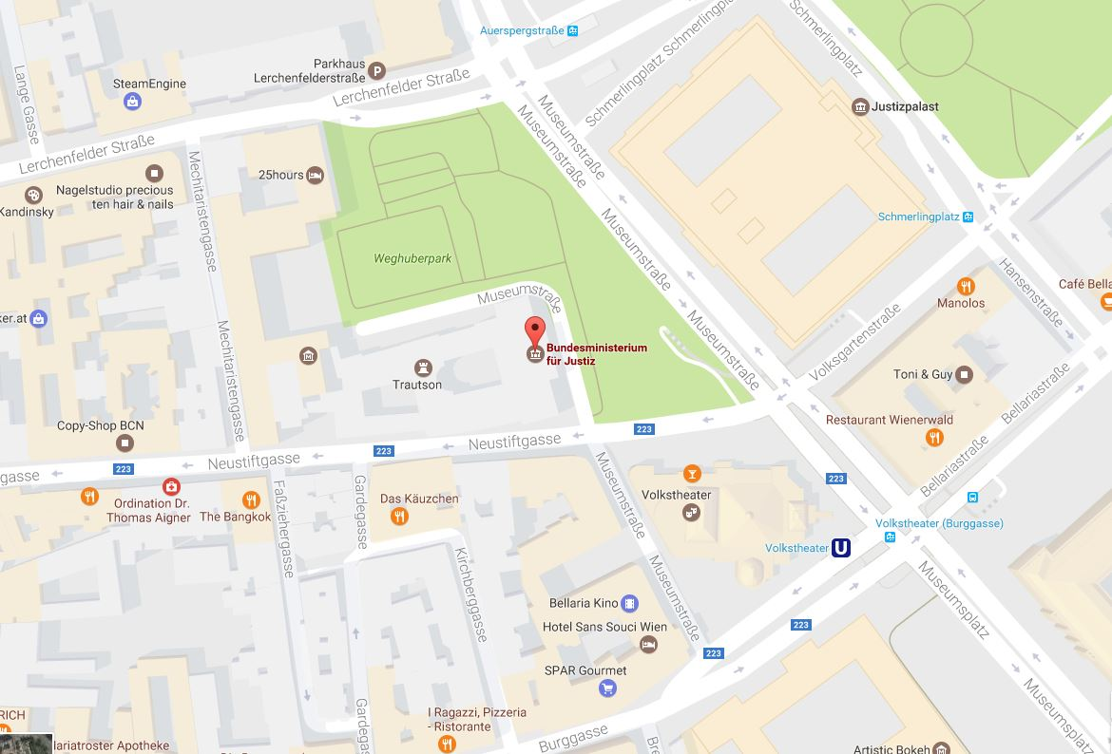

Hotels close to the venue
- Hotel Viennart (http://austrotel.at/hotel-viennart/): Breite Gasse 9, 1070 Vienna.
- Hotel-Pension Museum (http://www.hotelmuseum.at/): Museumstraße 3, 1070 Vienna.
- Hotel Zipser (http://hotel-vienna.travel/): Lange Gasse 49, 1080 Vienna.

Directions from the airport:

Arriving at Vienna International Airport you have several options to get to the place of the venue and to the suggested hotels. Look at the monitors to see which connection is available next:
- Take the shuttle bus (Vienna Airport Line) to "VOLKSTHEATER” (Bellariastraße). The easiest and cheapest way (every 30 minutes)! The place of the venue is within a few minutes walking distance.
- Take the shuttle bus (Vienna Airport Line) to "Westbahnhof". From there take the underground U3 to "VOLKSTHEATER" (Direction Simmering). The place of the venue is within a few minutes walking distance.
- Take the fast train “CAT” to Vienna City. From there take the underground U3 to "VOLKSTHEATER" (Direction Ottakring). The place of the venue is within a few minutes walking distance.
- Take a regional train (S-Bahn) to Wien Mitte-Landstraße (Direction Wien Floridsdorf). From there take the underground U3 to "VOLKSTHEATER" (Direction Ottakring). The place of the venue is within a few minutes walking distance.

Bus-tickets are available on the bus, for all other tickets there are Ticket machines.

DETOUR - Towards Pre-trial Detention as Ultima Ratio
Project period: 01 January 2016 – 31 December 2017
Funded by: Justice Programme of the European Commission

Why DETOUR?
In the 47 Member States of the Council of Europe more than 325.000 prisoners are held in pre-trial detention, more than 100.000 of them in the 28 Member States of the European Union. Pre-trial detention serves above all procedural purposes: to prevent a suspect from absconding, or from tampering with evidence. The justice systems must have a way of ensuring that those accused stand trial. Furthermore, detention may be a measure necessary because of a high risk that the suspect carries out (further) offenses of a severe nature. Often, however, detention seems just the easiest way of achieving this end. This is contrary to the principle that, with respect to the fundamental right to liberty and the presumption of innocence, deprivation of liberty must only be applied when less severe mechanisms are insufficient to exercise control over the suspect and to guarantee his or her presence at trial (as ultima ratio). Generally, the principle of subsidiarity must be applied in a way that the suspect or accused may await the trial process in conditions of unrestricted liberty or, where justified, under specified restrictions. In prisons, remand detainees often suffer from worse conditions than sentenced prisoners - the European Committee for the Prevention of Torture (CPT) has called this a pan-European problem. Another common problem is an often-observed excessive length of pre-trial detention. It must also be noted that in many European jurisdictions there is a particularly high proportion of foreigners in pre-trial detention.
To uphold the fundamental right to freedom as well the presumption of innocence for the suspect by avoiding pre-trial detention also means to avoid harm for indirectly affected people like children or spouses and to avoid costs to affected persons and to society as a whole. The European Convention of Human Rights and initiatives by the European Union show that member states share common values in this regard at least to a certain degree. This is further expressed in recommendations by the Council of Europe in this field, for example on prisoners’ rights. But even if there is a common set of values, differences in legal systems as well as the variance in pre-trial detention rates in the member states indicate that there are considerable discrepancies in how the ultima ratio principle is put into practice, which cannot be explained by differences with respect to the crime structure or to social conditions.
Without questioning the sovereignty of the member states in criminal matters, the increasing need for transnational cooperation and the increasing number of cross border cases ask for mutual understanding. Mutual understanding and trust, however, are built up best on the basis of knowledge about the systems, procedures and practice in other countries as well as on the basis of common standards. The DETOUR-project aims at both: The project is about exploring and analyzing pre-trial detention practice and especially ways of reducing the use of pre-trial detention in seven European jurisdictions (Austria, Germany, Romania, Belgium, Lithuania, Ireland and the Netherlands).
After thorough desktop research on the legal preconditions and on the overall context of pre-trial detention in the participating countries, the first step of the empirical work consisted of collecting and analyzing qualitative data by conducting observations and file analyses. This data provided the basis for in-depth interviews with a strong focus on the stance of prosecutors and judges and how they assess the decision-making process in the pre-trial phase. We consider that the views, perceptions and experiences of the judiciary are crucial to avoid pre-trial detention. We therefore put special emphasis on their assessment of the legal provisions, of the availability of alternatives, as well as of problems and obstacles relevant for the avoidance of pre-trial detention. To broaden the picture, we also included the perceptions and views of attorneys, as well as of representatives of (third sector or state) organizations offering their services to avoid pre-trial detention. Of particular interest were also the high numbers of foreigners in pre-trial detention in many countries and the increasing number of cross-border cases that need to be solved within the EU.
Considering the focus of the project on the actual practice the practitioners are on the one hand the persons most important for the collection of empirical information. On the other hand, they are also central addressees of the outcomes of the project.

Project Coordination - Verein für Rechts- und Kriminalsoziologie: Dr. Walter Hammerschick, Veronika Reidinger (Austria)
Scientific Co-coordinator - Ernst-Moritz-Arndt Universität Greifswald/Freie Universität Berlin: Prof. Dr. Christine Morgenstern, Eva Tanz (Germany)
Partners:
- Nationaal Instituut voor Criminalistiek en Criminologie / Institut National de Criminalistique et de Criminologie (NICC/INCC): Dr. Eric Maes, Dr. Alexia Jonckheere, Magali Deblock (Belgium)
- Utrecht University: Prof. Dr. Miranda Boone, Dr. Pauline Jacobs, Dr. J.M.W. Lindeman (The Netherlands)
- Association of Schools of Social Work in Romania/ University of Bucharest, Faculty of Sociology and Social Work: Prof. Dr. Ioan Durnescu, Dr. Gabriel Oancea (Romania)
- Law Institute of Lithuania: Dr. Skirmantas Bikelis, Virgilijus Pajaujis (Lithuania)
- Trinity College Dublin: Prof. Mary Rogan, David Perry (Ireland)

See more details and reports on our project website www.irks.at/detour

